DS Lab Week #6

Angad Sandhu
190905494
1/04/2022

solved questions

1)

#server.py

import socket
import datetime
import time

# function used to initiate the Clock Server
def initiateClockServer():
s = socket.socket()
print("Socket successfully created")
# Server port
port = 8011
s.bind(('', port))
# Start listening to requests
s.listen(5)
print("Socket is listening...")
# Clock Server Running forever
while True:
# Establish connection with client
connection, address = s.accept()
print('Server connected to', address)
# Respond the client with server clock time
connection.send(str(datetime.datetime.now()).encode())
# Close the connection with the client process
connection.close()

# Driver function
if __name__ == '__main__':
# Trigger the Clock Server
initiateClockServer()

#client.py

import socket
import datetime
from dateutil import parser
from timeit import default_timer as timer

# function used to Synchronize client process time
def synchronizeTime():
s = socket.socket()
# Server port
port = 8011
# connect to the clock server on local computer
s.connect(('127.0.0.1', port))
request_time = timer()
# receive data from the server
server_time = parser.parse(s.recv(1024).decode())
response_time = timer()
actual_time = datetime.datetime.now()
print("Time returned by server: " + str(server_time))
process_delay_latency = response_time - request_time
print("Process Delay latency: " + str(process_delay_latency) + " seconds")
print("Actual clock time at client side: " + str(actual_time))
# synchronize process client clock time
client_time = server_time + datetime.timedelta(seconds = (process_delay_latency) / 2)
print("Synchronized process client time: " + str(client_time))
# calculate synchronization error
error = actual_time - client_time
print("Synchronization error : " + str(error.total_seconds()) + " seconds")
s.close()

# Driver function
if __name__ == '__main__':
# synchronize time using clock server
synchronizeTime()

Output:
Server
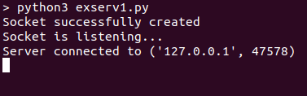
Client
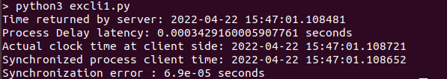

2)

#server.py

from functools import reduce
from dateutil import parser
import threading
import datetime
import socket
import time

# datastructure used to store client address and clock data
client_data = {}

''' nested thread function used to receive
clock time from a connected client '''
def startRecieveingClockTime(connector, address):

while True:
# recieve clock time
clock_time_string = connector.recv(1024).decode()
clock_time = parser.parse(clock_time_string)
clock_time_diff = datetime.datetime.now() - \
clock_time

client_data[address] = {
"clock_time" : clock_time,
"time_difference" : clock_time_diff,
"connector" : connector
}

print("Client Data updated with: "+ str(address),
end = "\n\n")
time.sleep(5)

''' master thread function used to open portal for
accepting clients over given port '''
def startConnecting(master_server):

# fetch clock time at slaves / clients
while True:
# accepting a client / slave clock client
master_slave_connector, addr = master_server.accept()
slave_address = str(addr[0]) + ":" + str(addr[1])

print(slave_address + " got connected successfully")

current_thread = threading.Thread(
target = startRecieveingClockTime,
args = (master_slave_connector,
slave_address, ))
current_thread.start()

# subroutine function used to fetch average clock difference
def getAverageClockDiff():

current_client_data = client_data.copy()

time_difference_list = list(client['time_difference']
for client_addr, client
in client_data.items())

sum_of_clock_difference = sum(time_difference_list, \
datetime.timedelta(0, 0))

average_clock_difference = sum_of_clock_difference \
/ len(client_data)

return average_clock_difference

def synchronizeAllClocks():

while True:

print("New synchroniztion cycle started.")
print("Number of clients to be synchronized: " + \
str(len(client_data)))

if len(client_data) > 0:

average_clock_difference = getAverageClockDiff()

for client_addr, client in client_data.items():
try:
synchronized_time = \
datetime.datetime.now() + \
average_clock_difference

client['connector'].send(str(
synchronized_time).encode())

except Exception as e:
print("Something went wrong while " + \
"sending synchronized time " + \
"through " + str(client_addr))

else :
print("No client data." + \
" Synchronization not applicable.")

print("\n\n")

time.sleep(5)

# function used to initiate the Clock Server / Master Node
def initiateClockServer(port = 8080):

master_server = socket.socket()
master_server.setsockopt(socket.SOL_SOCKET, socket.SO_REUSEADDR, 1)

print("Socket at master node created successfully\n")

master_server.bind(('', port))

# Start listening to requests
master_server.listen(10)
print("Clock server started...\n")

# start making connections
print("Starting to make connections...\n")
master_thread = threading.Thread(
target = startConnecting,
args = (master_server, ))
master_thread.start()

# start synchroniztion
print("Starting synchronization parallely...\n")
sync_thread = threading.Thread(
target = synchronizeAllClocks,
args = ())
sync_thread.start()

# Driver function
if __name__ == '__main__':

# Trigger the Clock Server
initiateClockServer(port = 8080)

#client.py

from timeit import default_timer as timer
from dateutil import parser
import threading
import datetime
import socket
import time

# client thread function used to send time at client side
def startSendingTime(slave_client):

while True:
# provide server with clock time at the client
slave_client.send(str(
datetime.datetime.now()).encode())

print("Recent time sent successfully",
end = "\n\n")
time.sleep(5)

# client thread function used to receive synchronized time
def startReceivingTime(slave_client):

while True:
# receive data from the server
Synchronized_time = parser.parse(
slave_client.recv(1024).decode())

print("Synchronized time at the client is: " + \
str(Synchronized_time),
end = "\n\n")

# function used to Synchronize client process time
def initiateSlaveClient(port = 8080):

slave_client = socket.socket()

# connect to the clock server on local computer
slave_client.connect(('127.0.0.1', port))

# start sending time to server
print("Starting to receive time from server\n")
send_time_thread = threading.Thread(
target = startSendingTime,
args = (slave_client, ))
send_time_thread.start()

# start recieving synchronized from server
print("Starting to recieving " + \
"synchronized time from server\n")
receive_time_thread = threading.Thread(
target = startReceivingTime,
args = (slave_client, ))
receive_time_thread.start()

# Driver function
if __name__ == '__main__':

# initialize the Slave / Client
initiateSlaveClient(port = 8080)

Output:
Server
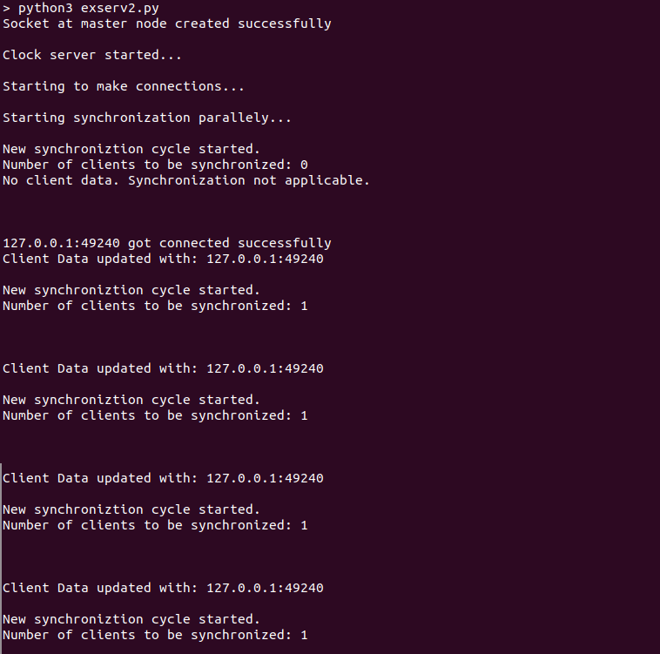

Client
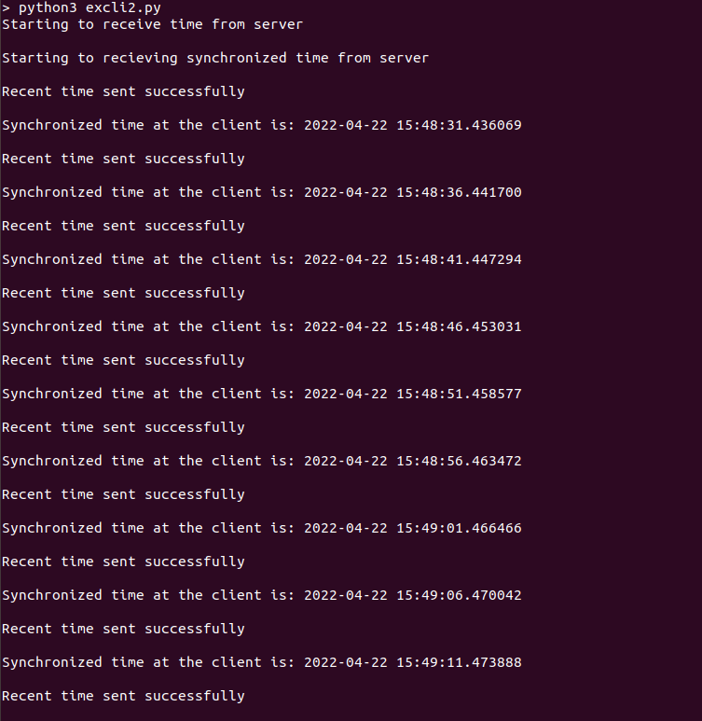

exersize questions

1)

#server.py

from functools import reduce
from dateutil import parser
import threading
import datetime
import socket
import time
client_data = {}
def startRecieveingClockTime(connector, address):
while True:
clock_time_string = connector.recv(1024).decode()
clock_time = parser.parse(clock_time_string)
clock_time_diff = datetime.datetime.now() - clock_time
client_data[address] = {
"clock_time": clock_time,
"time_difference": clock_time_diff,
"connector": connector
}
print("Client Data updated with: " + str(address), end="\n\n")
time.sleep(5)

def startConnecting(master_server):
while True:
master_slave_connector, addr = master_server.accept()
slave_address = str(addr[0]) + ":" + str(addr[1])
print(slave_address + " got connected successfully")
current_thread = threading.Thread(
target=startRecieveingClockTime,
args=(master_slave_connector, slave_address, ))
current_thread.start()

def getAverageClockDiff():
current_client_data = client_data.copy()
time_difference_list = list(client['time_difference']
for client_addr, client in client_data.items())
sum_of_clock_difference = sum(
time_difference_list, datetime.timedelta(0, 0))
average_clock_difference = sum_of_clock_difference / len(client_data)
return average_clock_difference

def synchronizeAllClocks():
while True:
print("New synchroniztion cycle started.")
print("Number of clients to be synchronized: " + str(len(client_data)))
if len(client_data) > 0:
average_clock_difference = getAverageClockDiff()
for client_addr, client in client_data.items():
try:
synchronized_time = datetime.datetime.now() + average_clock_difference
client['connector'].send(str(synchronized_time).encode())
except Exception as e:
print("Something went wrong while sending synchronized time through" + str(client_addr))
else:
print("No client data. Synchronization not applicable.")
print("\n\n")
time.sleep(5)

def initiateClockServer(port=8059):
master_server = socket.socket()
master_server.setsockopt(socket.SOL_SOCKET, socket.SO_REUSEADDR, 1)
print("The Manipal Foodie\n")
master_server.bind(('', port))
master_server.listen(10)
print("Clock server print\n")
print("Connecitng to production lines...\n")
master_thread = threading.Thread(
target=startConnecting,
args=(master_server, ))
master_thread.start()
print("Starting synchronization parallely...\n")
sync_thread = threading.Thread(
target=synchronizeAllClocks,
args=())
sync_thread.start()

if __name__ == '__main__':
initiateClockServer(port=8059)

#client1.py

from timeit import default_timer as timer
from dateutil import parser
import threading
import datetime
import socket
import time
def startSendingTime(slave_client):
while True:
slave_client.send(str(datetime.datetime.now()).encode())
print("KMC time sent successfully", end="\n\n")
time.sleep(5)

def startReceivingTime(slave_client):
while True:
Synchronized_time = parser.parse(slave_client.recv(1024).decode())
print("Synchronized time at the client is: " +
str(Synchronized_time), end="\n\n")

def initiateSlaveClient(port=8059):
slave_client = socket.socket()
slave_client.connect(('127.0.0.1', port))
print("Starting to receive time from server\n")
send_time_thread = threading.Thread(
target=startSendingTime,
args=(slave_client, ))
send_time_thread.start()
print("Starting to recieving synchronized time from server\n")
receive_time_thread = threading.Thread(
target=startReceivingTime,
args=(slave_client, ))
receive_time_thread.start()

if __name__ == '__main__':
initiateSlaveClient(port=8059)

#client2.py

from timeit import default_timer as timer
from dateutil import parser
import threading
import datetime
import socket
import time

def startSendingTime(slave_client):
while True:
slave_client.send(str(datetime.datetime.now()).encode())
print("MIT time sent successfully", end="\n\n")
time.sleep(5)

def startReceivingTime(slave_client):
while True:
Synchronized_time = parser.parse(slave_client.recv(1024).decode())
print("Synchronized time at the client is: " +
str(Synchronized_time), end="\n\n")

def initiateSlaveClient(port=8059):
slave_client = socket.socket()
slave_client.connect(('127.0.0.1', port))
print("Starting to receive time from server\n")
send_time_thread = threading.Thread(
target=startSendingTime,
args=(slave_client, ))
send_time_thread.start()
print("Starting to recieving synchronized time from server\n")
receive_time_thread = threading.Thread(
target=startReceivingTime,
args=(slave_client, ))
receive_time_thread.start()

if __name__ == '__main__':
initiateSlaveClient(port=8059)

#client3.py

from timeit import default_timer as timer
from dateutil import parser
import threading
import datetime
import socket
import time

def startSendingTime(slave_client):
while True:
slave_client.send(str(datetime.datetime.now()).encode())
print("TAPMI time sent successfully", end="\n\n")
time.sleep(5)

def startReceivingTime(slave_client):
while True:
Synchronized_time = parser.parse(slave_client.recv(1024).decode())
print("Synchronized time at the client is: " +
str(Synchronized_time), end="\n\n")

def initiateSlaveClient(port=8059):
slave_client = socket.socket()
slave_client.connect(('127.0.0.1', port))
print("Starting to receive time from server\n")
send_time_thread = threading.Thread(
target=startSendingTime,
args=(slave_client, ))
send_time_thread.start()
print("Starting to recieving synchronized time from server\n")
receive_time_thread = threading.Thread(
target=startReceivingTime,
args=(slave_client, ))
receive_time_thread.start()

if __name__ == '__main__':
initiateSlaveClient(port=8059)

#client4.py

from timeit import default_timer as timer
from dateutil import parser
import threading
import datetime
import socket
import time

def startSendingTime(slave_client):
while True:
slave_client.send(str(datetime.datetime.now()).encode())
print("SOLS time sent successfully", end="\n\n")
time.sleep(5)

def startReceivingTime(slave_client):
while True:
Synchronized_time = parser.parse(slave_client.recv(1024).decode())
print("Synchronized time at the client is: " + str(Synchronized_time), end="\n\n")
def initiateSlaveClient(port=8059):
slave_client = socket.socket()
slave_client.connect(('127.0.0.1', port))
print("Starting to receive time from server\n")
send_time_thread = threading.Thread(
target=startSendingTime,
args=(slave_client, ))
send_time_thread.start()
print("Starting to recieving synchronized time from server\n")
receive_time_thread = threading.Thread(
target=startReceivingTime,
args=(slave_client, ))
receive_time_thread.start()

if __name__ == '__main__':
initiateSlaveClient(port=8059)
Output:
Server:

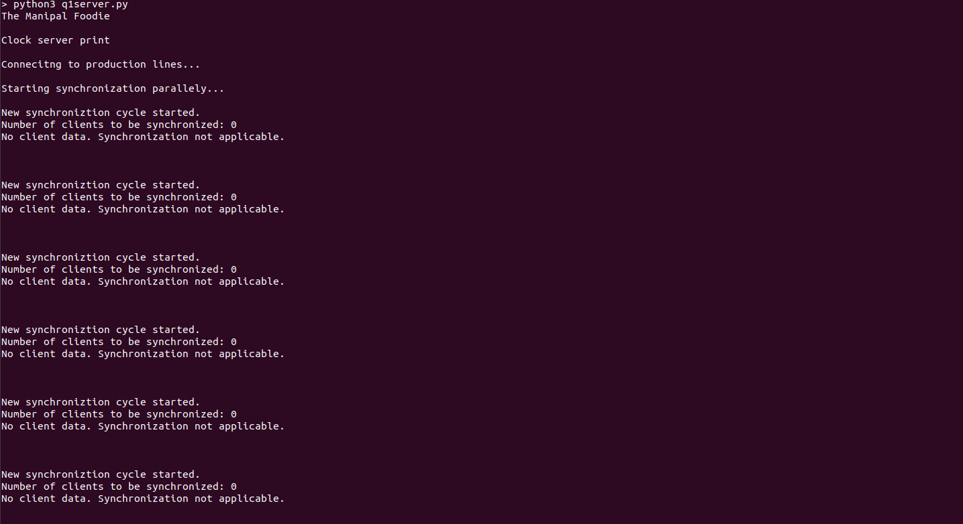
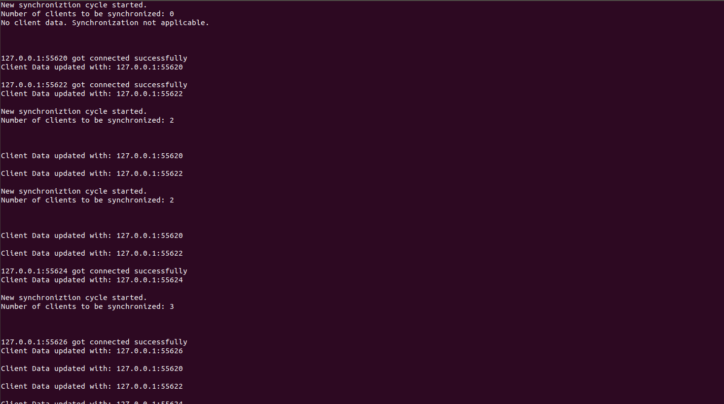

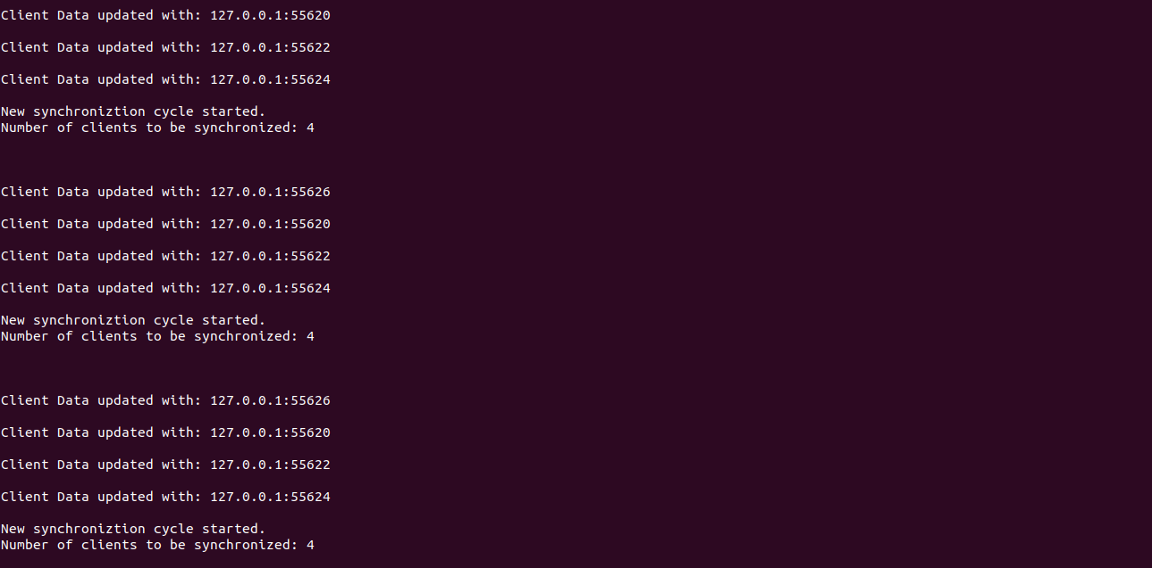

Client 1 & Client 2
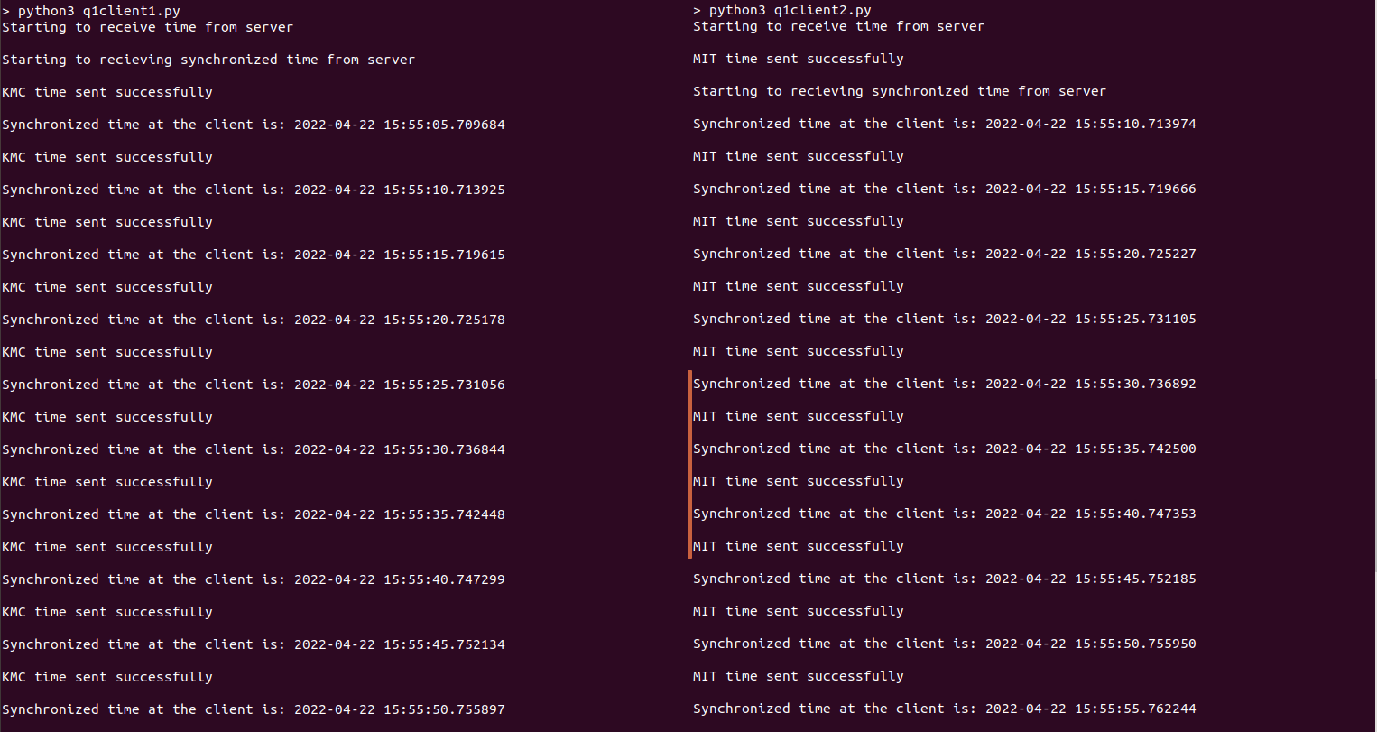

Client 3 & Client 4
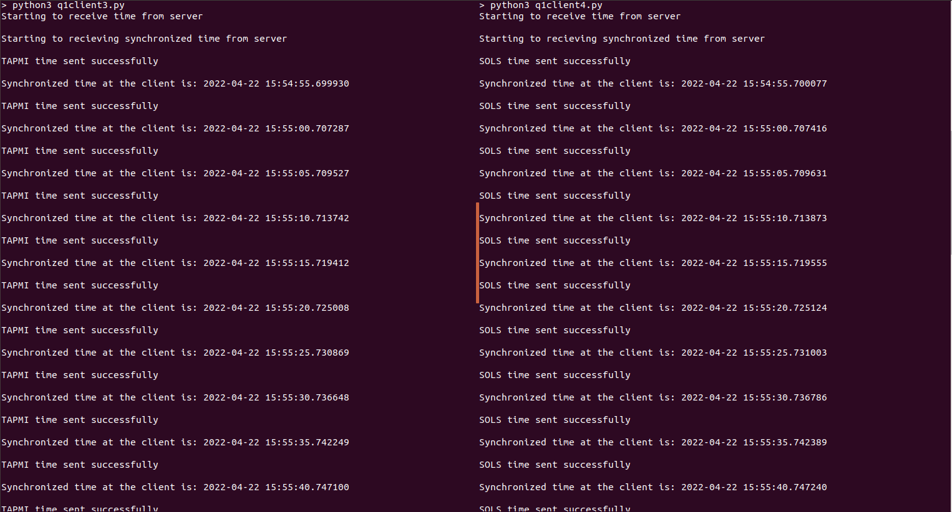
2)

#server.py

import socket
import datetime
import time

def initiateClockServer():
s = socket.socket()
print("Manipal Buddy Banking")
port = 8011
s.bind(('', port))
s.listen(5)
print("Waiting for client...")
while True:
connection, address = s.accept()
print('Server connected to', address)
connection.send(str(datetime.datetime.now()).encode())
connection.close()

if __name__ == '__main__':
initiateClockServer()

#client1.py
import socket
import datetime
import time
from dateutil import parser
from timeit import default_timer as timer

def synchronizeTime():
print("MOBILE APP\n")
s = socket.socket()
port = 8011
s.connect(('127.0.0.1', port))
request_time = timer()
server_time = parser.parse(s.recv(1024).decode())
response_time = timer()
actual_time = datetime.datetime.now()
print("Time returned by server: " + str(server_time))
process_delay_latency = response_time - request_time
print("Process Delay latency: " + str(process_delay_latency) + " seconds")
print("Actual clock time at client side: " + str(actual_time))
client_time = server_time + \
datetime.timedelta(seconds=(process_delay_latency) / 2)
print("Synchronized process client time: " + str(client_time))
time.sleep(10)
s.close()

if __name__ == '__main__':
synchronizeTime()

#client2.py

import socket
import datetime
import time
from dateutil import parser
from timeit import default_timer as timer

def synchronizeTime():
print("WEB BROWSER\n")
s = socket.socket()
port = 8011
s.connect(('127.0.0.1', port))
request_time = timer()
server_time = parser.parse(s.recv(1024).decode())
response_time = timer()
actual_time = datetime.datetime.now()
print("Time returned by server: " + str(server_time))
process_delay_latency = response_time - request_time
print("Process Delay latency: " + str(process_delay_latency) + " seconds")
print("Actual clock time at client side: " + str(actual_time))
client_time = server_time + datetime.timedelta(seconds = (process_delay_latency) /2)
print("Synchronized process client time: " + str(client_time))
time.sleep(10)
s.close()

if __name__ == '__main__':
synchronizeTime()

Output:
Server
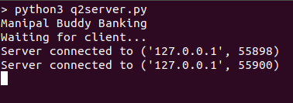
Client1
Client2

